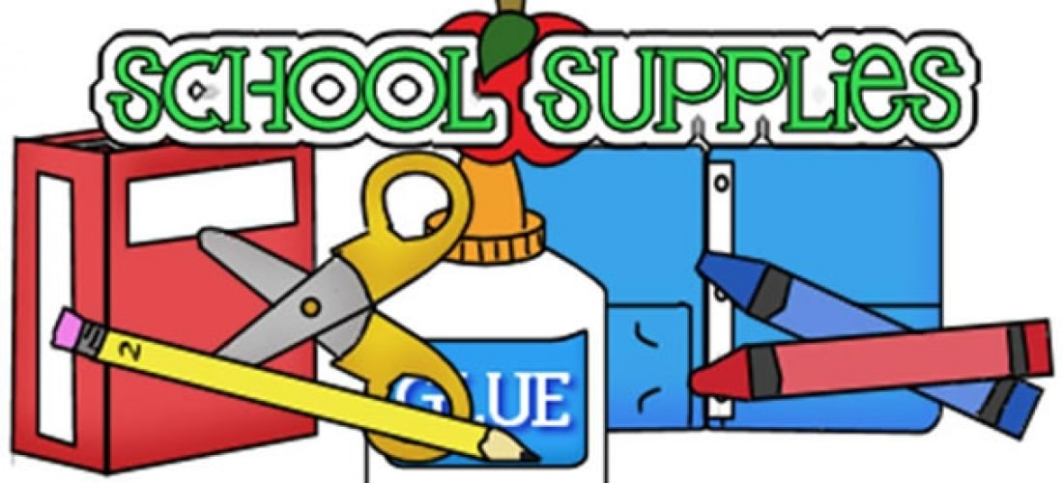

Third Grade List

1 pack of #2 pencils pre-sharpened (no mechanical pencils please)

1 set of headphones or earbuds (to go with the school chromebooks)

4 block erasers

1 box of Kleenex

1 container of Clorox wipes (girls please bring these)

2 highlighters any colors

1 roll of paper towels (boys please bring these)

2 8-pack of dry erase markers

1 composition notebook

1 plastic ruler (inches and centimeters)

1 box colored pencils

1 package of glue sticks (girls please bring these)

1 bottle of glue (boys please bring this)

1 pair of scissors

1 plastic folder with 2 pockets (labeled as “Homework Folder” with your child’s name and grade on the front)

1 clear, non-colored, plastic water bottle labeled with your child’s name on it for use all year

All students are welcome to bring a 26 inch exercise ball to use in the classroom in place of a chair!

 